My project aim to predict the 18-19 regular season MVP(most valuable player) of NBA.

1. My training model result which is the error :

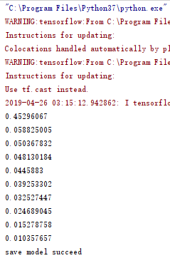

We can see from the above image the error is getting less, so it’s good.

1. We are going to test the model we just trained, we will use 5 years to do the test. The order of each player just like the known MVP order. We just see if the first one is the one who has the most MVP score.

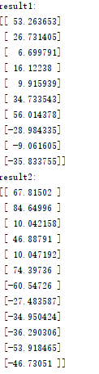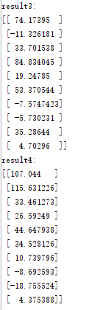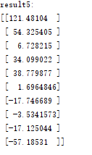

Actually the result is not so good. But I already adjust loss function, activation function and training function. Neither of those seems work. But we still did the prediction.

1. make prediction:

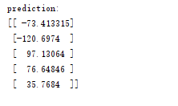

I did this final prediction many times and the third number seems to be the largest number most time. And the third one is Giannis Antetokounmpo which is known as Greek freak. Actually he is the one being the most potential MVP player for this season.